1. The input to this system is Istim, which is the input stimulation current. The output for this system is dE/dt (essentially E), which is the voltage of the membrane of the Ganglion Cell.

In the retina, as light hits the photoreceptors, the photoreceptors stimulate the Ganglion cells that they are connected to. This stimulation is modeled at Istim in our model. An increase in light hitting the retina activates more photoreceptors, which increases the stimulation on the Ganglion, which in turn should make the Ganglion fire more AP’s/AP’s more quickly. This is exactly what we see in the completed model.

1. The results for Exercise 2 are as follows: 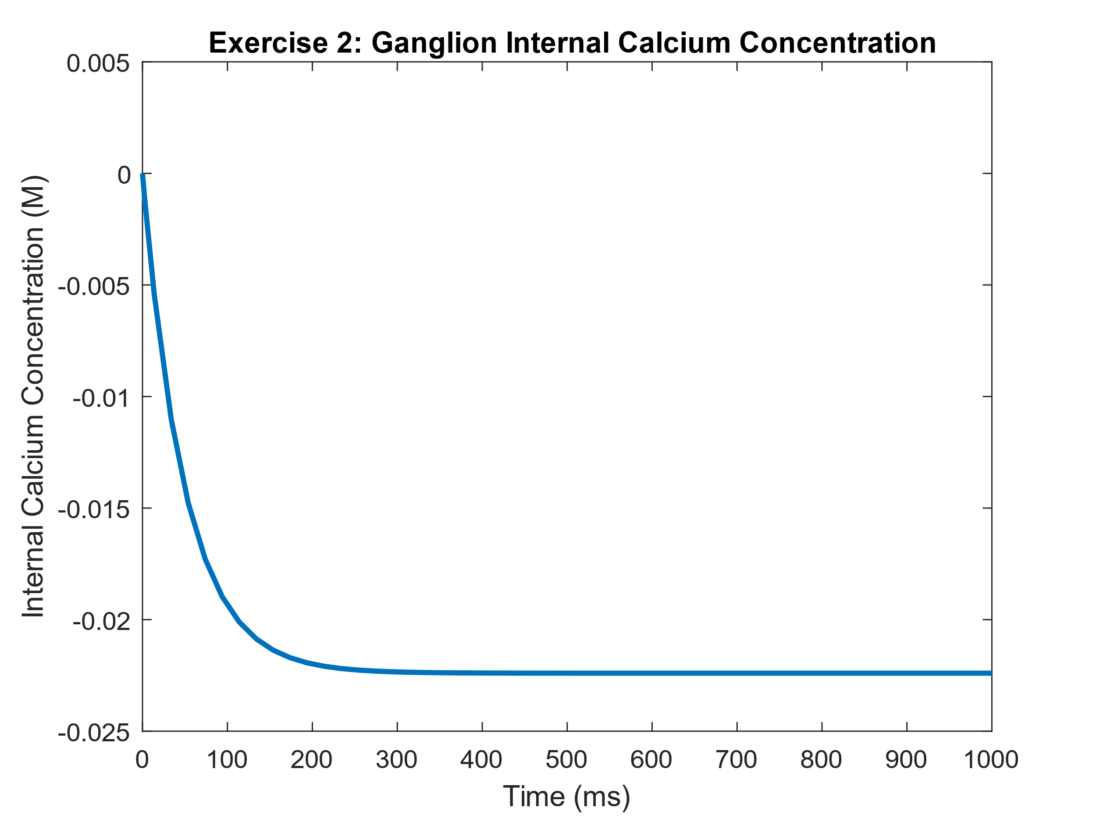

This figure shows how the internal concertation of Calcium changes over time for the neuron at rest.

1. The results for Exercise 3 are as follows:

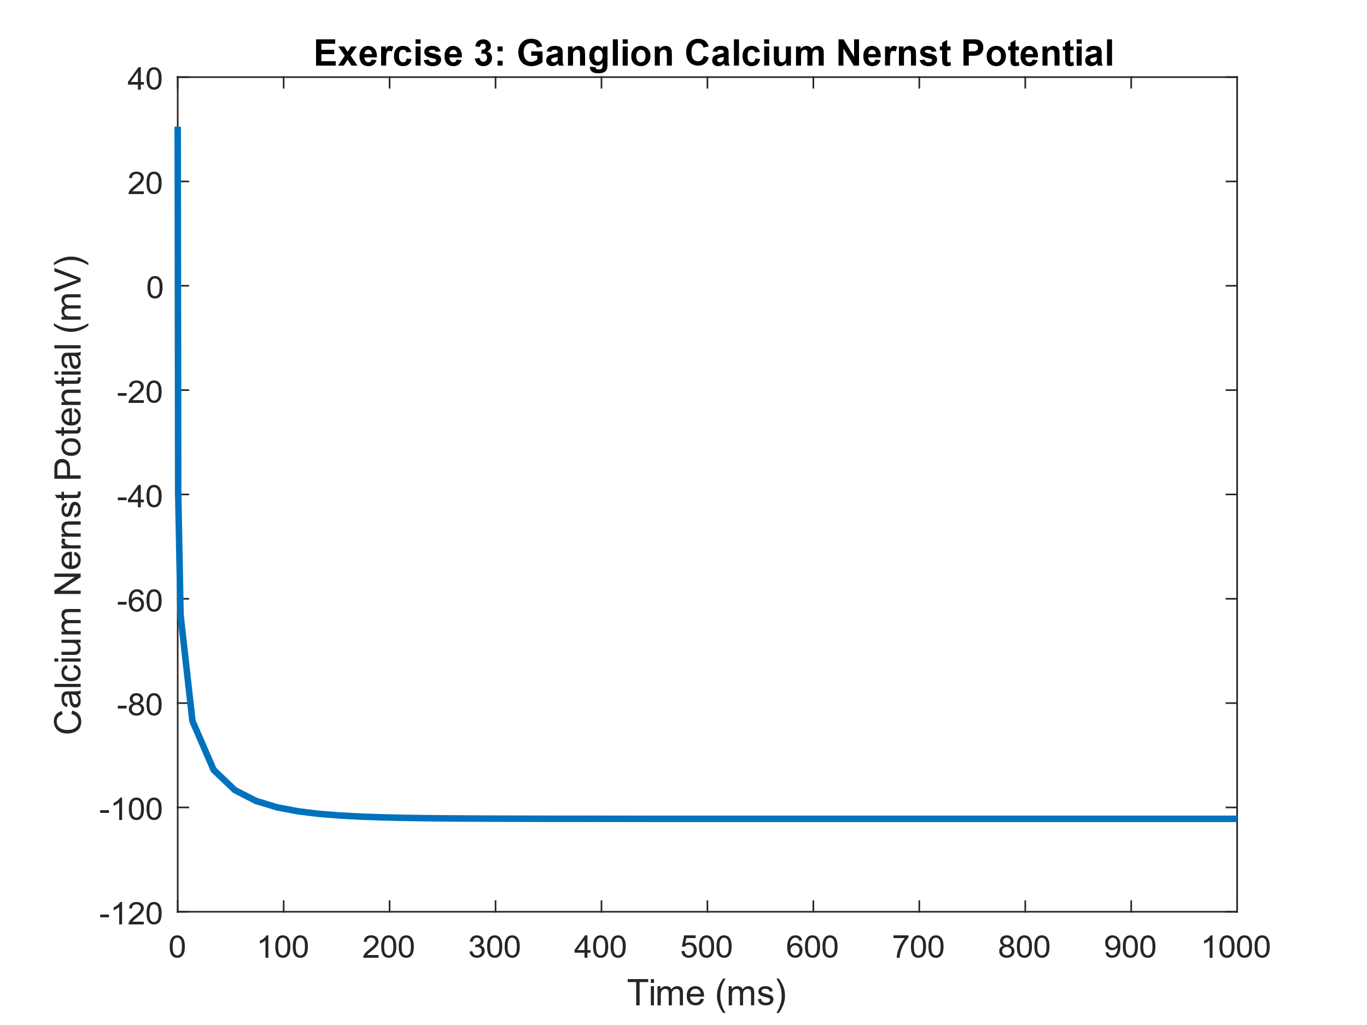

This Figure shows how the Nernst potential of calcium changes over time for the neuron at rest. This is directly coupled to the internal concentration of Ca++, from exercise 2

1. The threshold value found for this cut down version of the model was very low. The threshold found was Istim = .03; The results for the section follow:

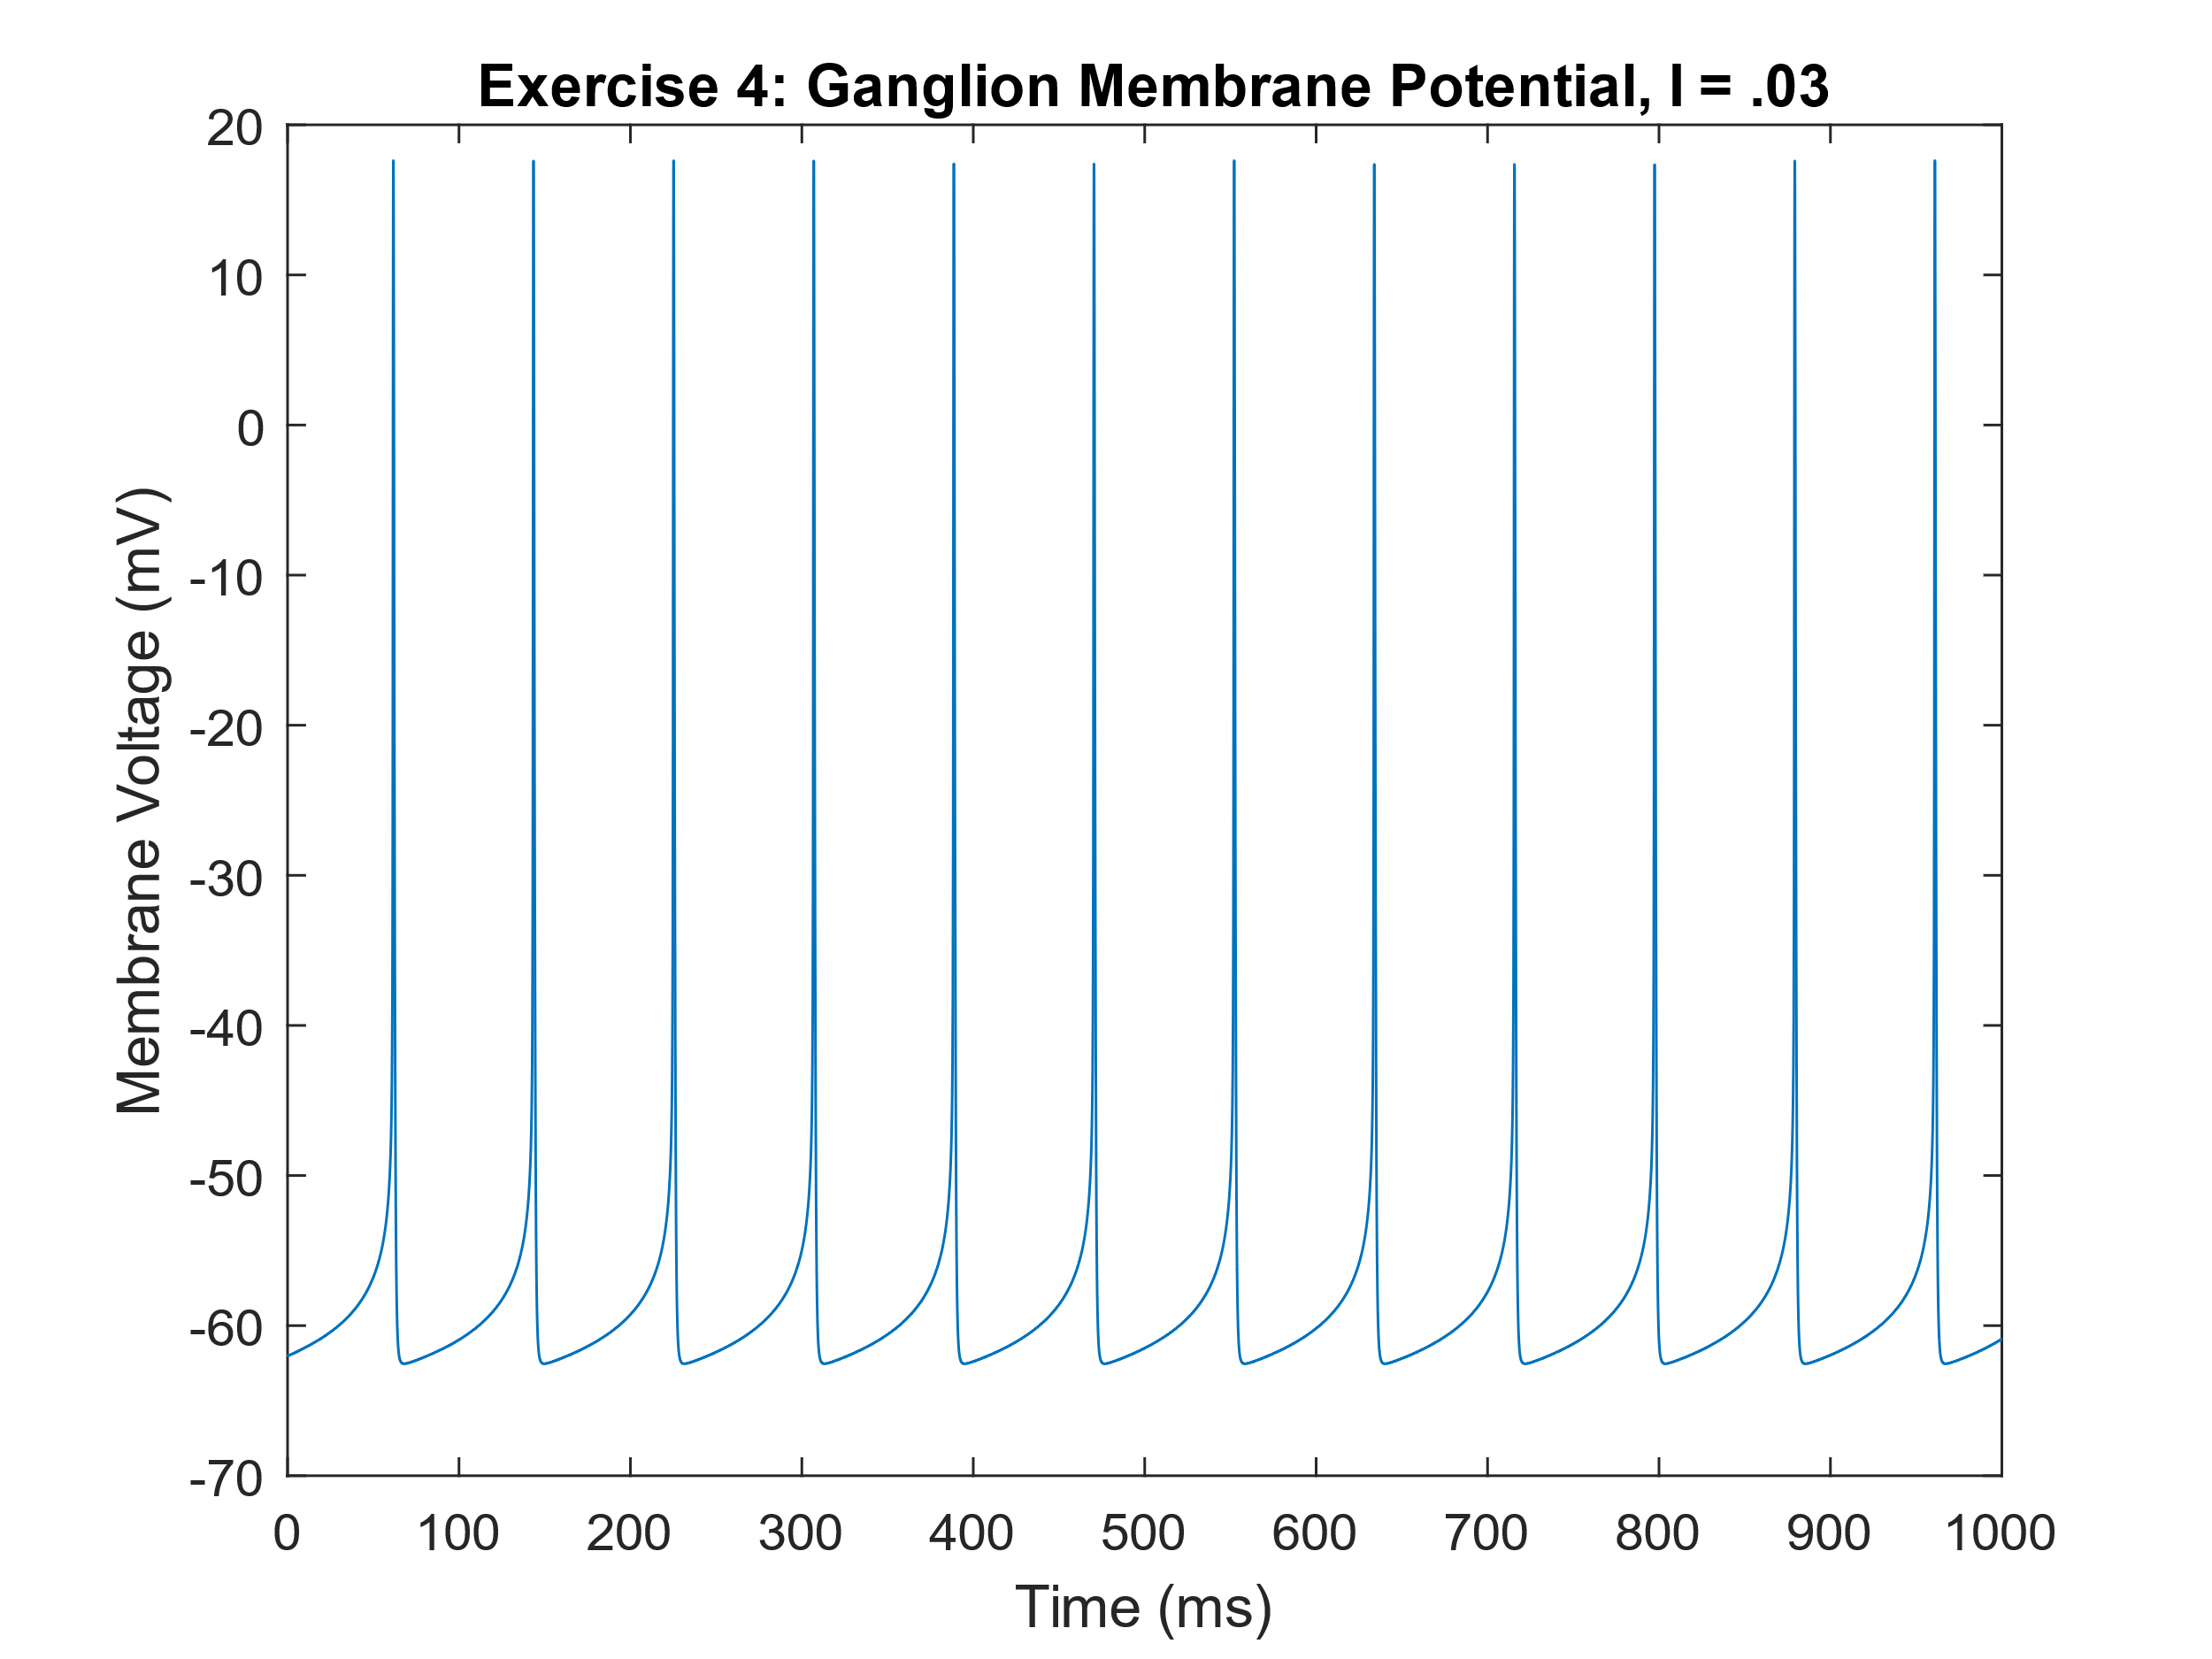

This figure shows the membrane voltage of the Ganglion Cell with respect to time. We can see well defined and consistently firing action potentials that form a spike train

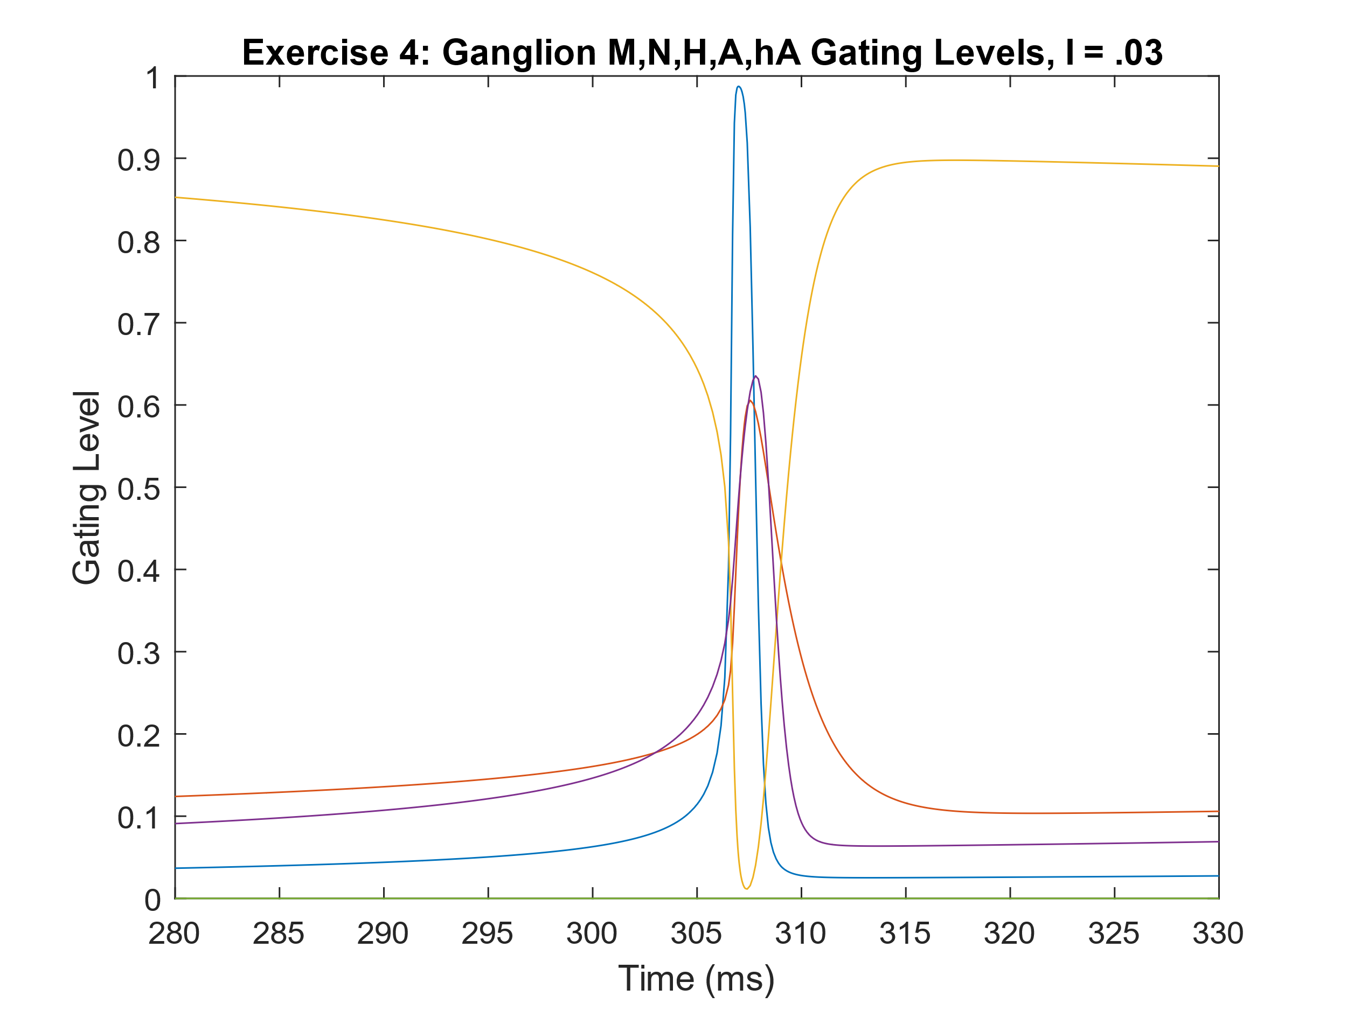

This figure shows how the values of M, N, H, A, hA change during a single action potential, for the cut-down model

1. For the full model, the threshold found was Istim = .67; The results of three different spike trains follow:

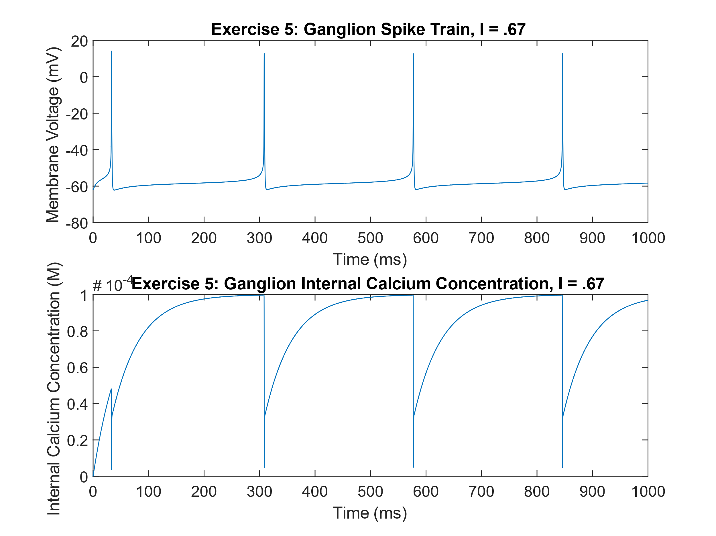

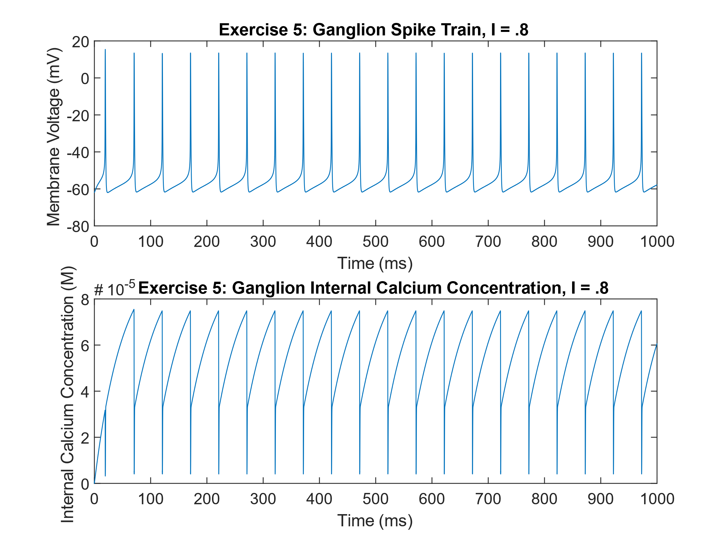

This figure shows membrane voltage and internal calcium concentration at the threshold stimulation current

This figure shows membrane voltage and internal calcium concentration at slightly above threshold stimulation current

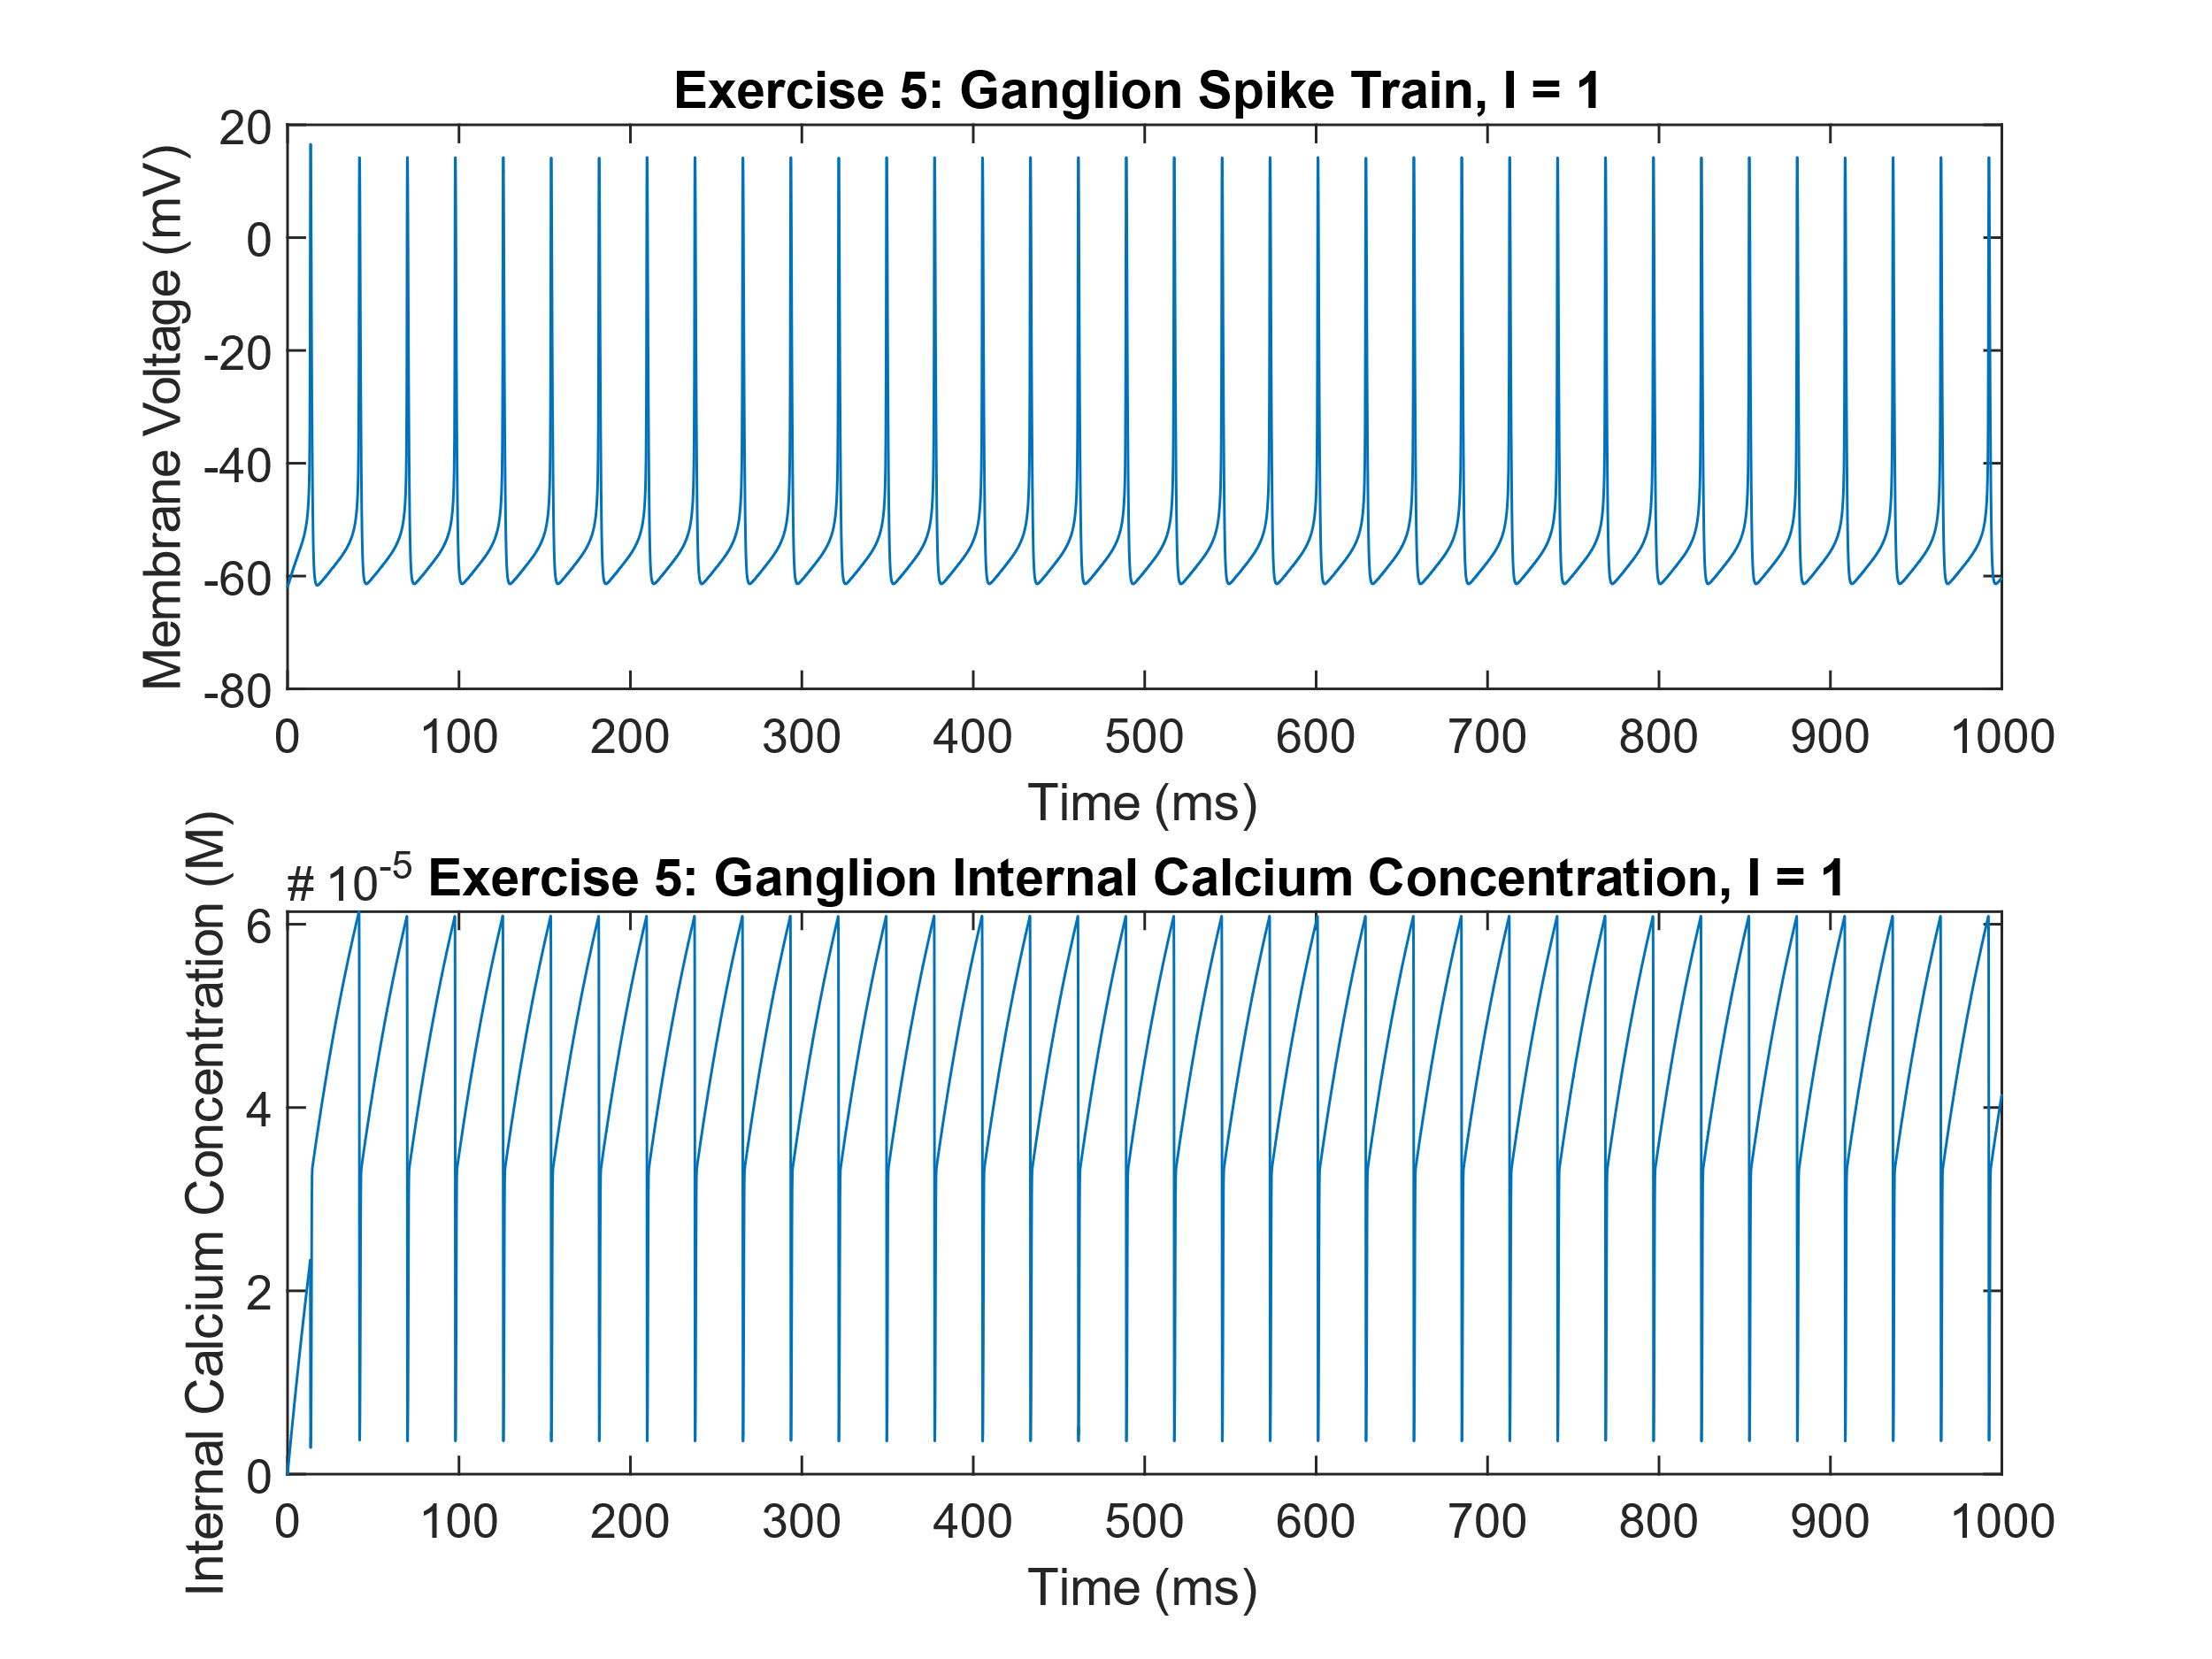

This figure shows membrane voltage and internal calcium concentration at significantly above threshold stimulation current

1. When compared to the original HH model, we see that even when using the reduced ganglion model, there are significant differences. First is that the Ganglion model is significantly more excitable than the HH model. This is the case as the stimulation current required is orders of magnitude lower than for HH. Further, we see that the spike onset for the ganglion model is more abrupt, wherein the HH model has a much more smooth rise to the peak. Further, once at the peak, the Ganglion model appears to slam back down to rest, while the HH model has a more gradual descent, just like with its ascent.

Further, the spike width of the Ganglion model is significantly more narrow than the spike produced by HH. Thinking about it by relating this model to the others we have seen, the spikes from the Ganglion model are quite similar to those of the quadratic integrate and fire model, and not very similar to HH, even though the structure of the equation is like that of HH.

Furthermore, from the Ganglion model, we see that there is a significantly lower refractory period, which results in higher frequency spike trains. These spike trains are much more dense than any spike trains the HH model can produce. Further, these spikes are of lower amplitude than HH, as they barely exceed 20mV, while HH can be in excess of 40mV at the peak.

1. The dynamic behavior that required the extra currents when compared to the standard HH would have to be the ability to produce dense spike trains. Further, these spike trains must be able to be produced at low stimulation currents. Thus, the two extra currents were required to allow the neuron to return to rest more quickly (lower refractory period) and thus allow for increased firing rates and the production of dense spike trains more easily.

This aligns with problem 1, as because of the requirements for lower stimulation currents and the production of dense spike trains, we have modified the HH model to have these extra two currents to produce this desired result.